**Git Steps for commit and rebase**

|  |  |  |
| --- | --- | --- |
| **Sl. No** | **Comments** | **Git Command** |
| 1 | Create your own branch from Master branch | From web portal |
| 2 | Clone the repository | git clone [repository url] |
| 3 | Checkout to your branch | Git checkout [branch name] |

Now start working on your branch and end of the day commit and push your code to your branch

|  |  |  |
| --- | --- | --- |
| **Sl. No** | **Comments** | **Git Command** |
| 1 | Add your changes to git | git add [file name] or [.(dot) for all file] |
| 2 | Commit and add message | git commit –m “Your msg” |
| 3 | Push your local changes to remote repository | git push |

Create Merge request from your branch to master through web

Next time before creating merge request to master do below steps

|  |  |  |
| --- | --- | --- |
| **Sl. No** | **Comments** | **Git Command** |
| 1 | Checkout to master Branch | git checkout master |
| 2 | Pull code of remote master to local master branch | git pull |
| 3 | Checkout to your branch | git checkout [Branch name] |
| 4 | Do rebase from master | git rebase master |

Doing above things you may get conflict if any other developer is working on same file

In that case do below steps

1. git status (it will show you which file have conflict)
2. Go to VS code and check that file and select appropriate action refer below picture

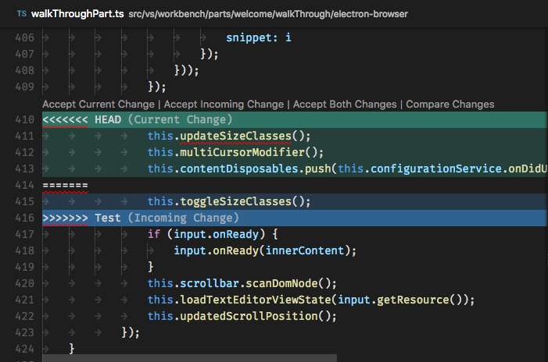

1. You will get three option
2. Accept current changes (Your changes)
3. Accept incoming changes (other developer changes)
4. Accept both (your and other developer changes)
5. Save the file after selecting above action
6. git add [your saved file]
7. git rebase –continue
8. git pull (you may get again conflict then do step 2 and 3)
9. git status
10. git commit esc:wq
11. git push